Ecoscapes: Freshwater and Land

*Freshwater, Scrub, and Oak forest Habitat*

By:

Sarah Callahan (Cooper City High School)

Francesca Dupuy (Cooper City High School)

Kendra Washington (Nova High School)

**Abstract**

In the “Background” section of this paper there is a description of the process that led up to building the app and why we chose the Ecoscapes exhibit. In the “Methods” section of the paper the responsibilities of each individual on the Ecoscapes team is discussed and how we worked as a team to integrate everything is also described. The Methods section also addresses how we found the information we wanted to include in our app and the obstacles we faced and how we worked to find solutions. In the “Results” portion of the paper there are several pictures and a description of what is included in the app. In “Discussion,” there are statements about what things need to be completed in the app and what improvements can be made in the future. “Conclusions “follows “Discussion” with some statements about how the team felt throughout the process of completing the app. To finish, there is a “Credits” section which gives thanks to all of the people and organizations that helped make the APPtitude program and the creation of our app possible.

**Background**

Our journey with the APPtitude program began in the fall of 2014 when we had our first orientation. Over the course of a year we learned the ins and outs of the Museum of Discovery and Science. We were able to choose our exhibits that we would like to create an app for and split into groups accordingly. Our team chose the Ecoscapes exhibit because we believed it to be one of the museum’s most attractive exhibits and felt that we could make it more interactive and educational. During our internship at the museum, we worked to refine what type of information we would like to include in our app and how we would like it to be presented. Before entering Florida Atlantic University, our group consisted of six people because Ecoscapes is such a large exhibit.  Every time we met at the Museum, the six of us would work together to gather information so that we could make the app more appealing to the museum audience. On our first day of class at FAU our six person group was divided into two. One group was to create an app for the saltwater portion of Ecoscapes and the other group to complete an app for the freshwater and land animals of Ecoscapes. Our group was assigned to the freshwater and land portion of Ecoscapes, and we promptly began to immerse ourselves into the app creation process.

**Methods**

The Ecoscapes Freshwater and Land team wanted to create a more entertaining and educational experience for visitors at the museum.  The team wanted visitors to be able to take away solid information about the animals they saw instead of just looking at the animals and walking away. In order to achieve this, information that was interesting was gathered from the internet to put into the slides. The slides of the animals were colorful and filled with cool, relevant, and memorable information. Joey the otter is seen introducing each of the animals and information about them to make it more kid friendly. The amount of text on each slide was kept to a minimum so as not to lose the user’s attention. The games were then placed on the last page of the Oak Forest and Scrub Habitat slides in order to force the user to come in contact with all the information that we have provided. Through the Trivia Madness and the Tortoise and the Hare game people are able to get involved with what they are learning.

Kendra Washington was responsible for developing the graphics for the app.  The theme of the app was a comic book look. A font named Jabjai was used throughout the app to make the comic theme more convincing. Photoshop was utilized to create the backgrounds, speech bubbles and characters.  Images were drawn by hand on lined paper and then traced within Photoshop to add depth and texture to the image. Joey the Otter, the tortoise, the hare, and the speech bubbles on the main page were created in this way.  The main background was done by adding different colored filters to the original blue image. The freshwater background was made to look blue, the scrub habitat background made to look orange, and the oak forest habitat made to look green. The background for the Tortoise and the Hare game was done by adding a filter to a 100% free image of a scrub habitat to make it more cartoon like.   The images of the animals that are utilized on the slides are free to use, modify, and share from the internet. Sarah Callahan was responsible for the User Interface (UI) development of the app. The team wanted to make sure that the layout was aesthetically pleasing and everything was easy to access and read. Sarah made sure that the font was big enough to read, but small enough to fit on the buttons. The team also wanted to ensure that the different activity screens of the app looked uniform, but different enough so that the user will know what section they are viewing, and not get confused or annoyed. Sarah chose a light to dark gradient to make the text easier to read and to make the pages more pleasing to the eye. Also to keep it uniformed we had Joey the otter introducing each animal throughout the different sections. Francesca Dupuy was responsible for the Java programming behind the app. In order to make the buttons and games work, the music play, and the popups come up, code was needed. Francesca was able to integrate Sarah’s UI into the app so that everything would work as a whole. Francesca also had to make sure that there were no “bugs” in the code so that the app would not crash on the tablet while in the hands of the user.

Whenever any of the team members came across problems in the app we would try to find solutions to fix them. For example, if any of the buttons or pictures did not fit right, or was proving difficult to place within Android Studios, the graphics designer edited it within Photoshop to meet the needed specifications for the user interface developer. If the java programmer came across errors in her code she would look to see if there were any simple mistakes first, then see if there were any solutions on stackoverflow.com, ask a teacher’s assistant for some help, or try to see if there was a way to get the same result but with a different method.

**Results**

The Ecoscapes Freshwater and Land app has five buttons on the home page. The first three buttons-Freshwater, Oak Forest, and Scrub- lead to another page where Joey the Otter can be seen introducing himself and saying come meet my friends. When the user clicks next there will be tabbed slides with pictures of the animals from that habitat with Joey the Otter giving some interesting information about each animal. After the slides in the Oak forest category there is a trivia game where questions with multiple choice answers will be asked. Furthermore, after the slides in the Scrub Habitat category there is a Tortoise and the Hare game where questions will pop up on the screen with true or false buttons. If the user gets the response correct the tortoise moves one step, however, if the user gets the response incorrect the hare moves. Whoever crosses the finish line first wins the game.

The other two buttons consist of the map and credits button which can be seen at the bottom of the home screen. The map button leads the user to an interactive map. When the user clicks on an exhibit they will be lead to a screen with a picture and short description of that exhibit. When the credits button is clicked a list of acknowledgements appears.

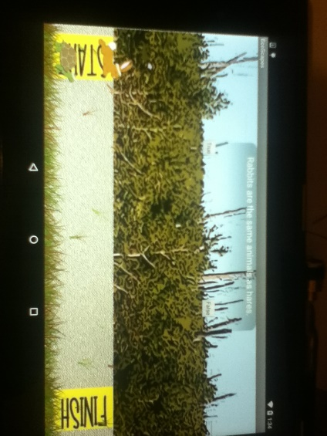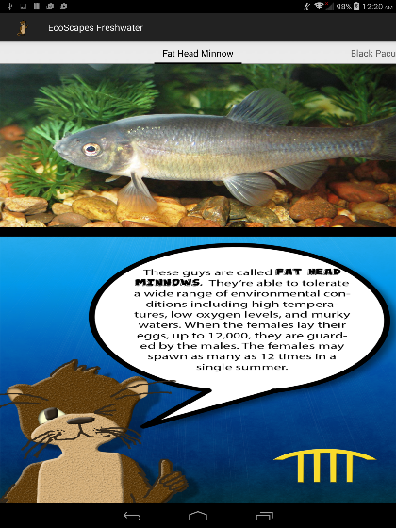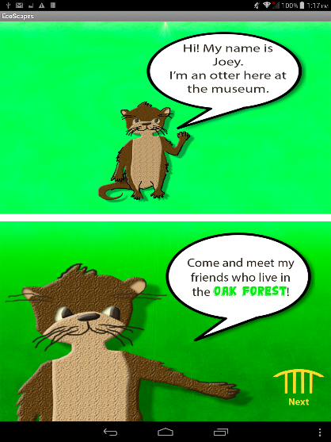

Beginning from left to right, the first picture is of the Tortoise and the Hare game. As described previously the question pops up at the top of the screen while the tortoise and hare can be seen at the bottom of the screen. The middle picture is of the Freshwater habitat slides where Joey can be seen introducing his friends. The last picture is of Joey the Otter introducing himself in the Oak Forest category and pointing to the next button so the user can move onto the slides.

**Discussion**

While the Ecoscapes Freshwater and Land team completed a heavy amount of work in the three weeks they had, with only nine official days of class, there are still improvements to be made throughout the app. At the moment, several buttons are on the screen but do not do anything. These buttons need some coding behind them so that they may lead to the next activity. Also, the Trivia Madness game for the Oak Forest Habitat is completed but needs to be connected to the main app through broadcast intents. The team would also like to add a game to the Freshwater activity section so that each habitat has a game to go along with it. Our team was considering creating a scavenger hunt-like game where the user has to enter how many animals they see in each tank. For example, they would have to count how many alligators there are and then enter the number. Rather than being in a trivia format, such a game would make sure that visitors are checking out the whole exhibit. Additionally, at the end of the scrub habitat game we would like to implement a Joey the Otter saying whether the Tortoise or the Hare wins the race. Last but not least, the team would like to make the main activity screen more attractive by making the speech bubbles evenly spaced.

**Conclusion**

Throughout the three weeks that the Ecoscapes team worked on the app there had been times where we were extremely excited, frustrated, and stressed. However, in the end we could not have been more elated to see what we were able to accomplish. Although, there are still improvements to be made we can say that the Ecoscapes Freshwater and Land app successfully complements the information and animals already found within the museum.  The people who do not care for reading the plaques about the animals might be more enthused about reading information in a bright and lively app.  The app appeals to a visitor’s sense of competitivity and encourages them to learn the information in order to succeed at the games. Also, the information we put in the app does not repeat what is already on the plaques. We did this so that people could learn more from the app. The information we chose to put in the app is information that would answer most people’s questions such as, is the animal dangerous, poisonous, male/female, rare, whether or not it could it be a pet, etc.

**Credits**

The authors would like to give thanks to Nova and Cooper City High School for giving us the opportunity to participate in this amazing experience. We would also like to thank all Museum of Discovery and Science staff, especially Mrs. Summer Scarlatelli and Mr. Joe Cytacki, for their patience and assistance. Additionally, we would like to show our gratitude toward Dr. Ravi Shankar (Coding for Google Android) and Professor Francis McAfee (Graphics) and their teacher’s assistants which included Santiago Aguerreverre, Alain Edwards, and Demetrius Dukes who taught us so many new things and gave us an enormous amount of support at the Florida Atlantic University campus. Furthermore, we would like to reference Hello Android by Ed Burnette and Android Studio Development Essentials by Neil Smythe, as both of these books helped immensely in the coding process. Also, without the Adobe Photoshop program the graphics created for this app would not have been possible. Lastly, we would like to give special thanks to the United Way of Broward County for the grant that helped start the APPtitude program.

**References**

Channel Catfish *Ictalurusnatalis*.<https://commons.wikimedia.org/wiki/File:Channel_Catfish.jpg>

<http://www.flmnh.ufl.edu/fish/gallery/descript/channelcatfish/channelcatfish.html>

Blue Gill *Lepomismacrochirus*[*https://ca.wikipedia.org/wiki/Fitxer:Bluegill_(lepomis_macrochirus).jpg*](https://ca.wikipedia.org/wiki/Fitxer:Bluegill_(lepomis_macrochirus).jpg)

[*http://www.biokids.umich.edu/critters/Lepomis_macrochirus/*](http://www.biokids.umich.edu/critters/Lepomis_macrochirus/)

Fat Head Minnow *Pimephalespromelas*[*https://commons.wikimedia.org/wiki/File:Fathead_minnow_-_breeding_male.jpg*](https://commons.wikimedia.org/wiki/File:Fathead_minnow_-_breeding_male.jpg)

[*https://tpwd.texas.gov/huntwild/wild/species/carpmin/*](https://tpwd.texas.gov/huntwild/wild/species/carpmin/)

Black Pacu *Colossomamacropomum*[*https://upload.wikimedia.org/wikipedia/commons/thumb/5/5f/Colossoma-brachypomus.jpg/300px-Colossoma-brachypomus.jpg*](https://upload.wikimedia.org/wikipedia/commons/thumb/5/5f/Colossoma-brachypomus.jpg/300px-Colossoma-brachypomus.jpg)

[*http://animal-world.com/encyclo/fresh/characins/BlackPacu.php*](http://animal-world.com/encyclo/fresh/characins/BlackPacu.php)

|  |
| --- |
| Scrub Habitat  Corn Snake *Pantherophisguttatus*[*http://farm4.staticflickr.com/3060/3001574112_f9ffb73480_z.jpg?zz=1*](http://farm4.staticflickr.com/3060/3001574112_f9ffb73480_z.jpg?zz=1)  <https://nationalzoo.si.edu/Animals/ReptilesAmphibians/Facts/FactSheets/Cornsnake.cfm>  Florida King Snake *Lampropeltisgetulusfloridana*[*https://upload.wikimedia.org/wikipedia/commons/1/1d/Speckled_king_snake_lampropeltis_getula_holbrooki_stejneger.jpg*](https://upload.wikimedia.org/wikipedia/commons/1/1d/Speckled_king_snake_lampropeltis_getula_holbrooki_stejneger.jpg)  <https://www.flmnh.ufl.edu/herpetology/fl-snakes/list/lampropeltis-getula-floridana/>  Eastern Indigo Snake *Drymarchoncouperi*[*https://upload.wikimedia.org/wikipedia/commons/2/2d/Indigo_snake_reptile.jpg*](https://upload.wikimedia.org/wikipedia/commons/2/2d/Indigo_snake_reptile.jpg)  <http://srelherp.uga.edu/snakes/drycou.htm>  Florida Water Snake *Nerodiafasciata*[*http://farm8.staticflickr.com/7100/6890988212_2af33c2fbf_z.jpg*](http://farm8.staticflickr.com/7100/6890988212_2af33c2fbf_z.jpg)  <https://www.flmnh.ufl.edu/herpetology/fl-snakes/list/nerodia-fasciata-pictiventris/>  Gopher tortoise  *Gopheruspolyphemus*[*https://upload.wikimedia.org/wikipedia/commons/e/e9/Gopher_tortoise_in_Punta_Gorda,_Florida_2.jpg*](https://upload.wikimedia.org/wikipedia/commons/e/e9/Gopher_tortoise_in_Punta_Gorda,_Florida_2.jpg)  <http://www.defenders.org/gopher-tortoise/basic-facts>  Florida Box Turtle *Terrapenecarolinabauri*[*http://farm8.staticflickr.com/7294/8912913138_17866c1821_z.jpg*](http://farm8.staticflickr.com/7294/8912913138_17866c1821_z.jpg)  [*http://www.boxturtles.com/florida-box-turtle/*](http://www.boxturtles.com/florida-box-turtle/)  Eastern Box Turtle *Terrapenecarolinacarolina*[*https://upload.wikimedia.org/wikipedia/commons/2/27/Eastern_box_turtle_in_florida.JPG*](https://upload.wikimedia.org/wikipedia/commons/2/27/Eastern_box_turtle_in_florida.JPG)  [*http://www.fcps.edu/islandcreekes/ecology/eastern_box_turtle.htm*](http://www.fcps.edu/islandcreekes/ecology/eastern_box_turtle.htm)  Three-toed box turtle *Terrapenecarolinatriunguis*[*http://www.birderslounge.com/wp-content/uploads/2009/07/20090615-AMC_2760-590x421.jpg*](http://www.birderslounge.com/wp-content/uploads/2009/07/20090615-AMC_2760-590x421.jpg)  <http://www.tortoisetrust.org/care/ctriungis.html>  Old World Rabbit *Oryctolaguscuniculus*[*https://c2.staticflickr.com/2/1224/536380994_ae786f2af5_z.jpg?zz=1*](https://c2.staticflickr.com/2/1224/536380994_ae786f2af5_z.jpg?zz=1)  [*http://www.oregonzoo.org/discover/animals/old-world-rabbit*](http://www.oregonzoo.org/discover/animals/old-world-rabbit)    Forest Habitat    Egyptian Fruit Bat *Rousettasaegyptiacus*[*https://c1.staticflickr.com/9/8519/8551127868_e095981f52_z.jpg*](https://c1.staticflickr.com/9/8519/8551127868_e095981f52_z.jpg)  [*http://www.batworlds.com/egyptian-fruit-bat/*](http://www.batworlds.com/egyptian-fruit-bat/)  Day Gecko *Phelsuma*[*https://upload.wikimedia.org/wikipedia/commons/d/d6/Madagascar_Giant_Day_Gecko.jpg*](https://upload.wikimedia.org/wikipedia/commons/d/d6/Madagascar_Giant_Day_Gecko.jpg)  [*http://www.arkive.org/day-gecko/phelsuma-antanosy/*](http://www.arkive.org/day-gecko/phelsuma-antanosy/)  Madagascar  Hissing Cockroach *Gromphadorinaportentosa*[*https://upload.wikimedia.org/wikipedia/commons/4/46/Female_Madagascar_hissing_cockroach.JPG*](https://upload.wikimedia.org/wikipedia/commons/4/46/Female_Madagascar_hissing_cockroach.JPG)  [*http://animals.nationalgeographic.com/animals/bugs/madagascar-hissing-cockroach/*](http://animals.nationalgeographic.com/animals/bugs/madagascar-hissing-cockroach/)  Desert Blond Tarantula Aphonopelmachalcodes<https://c1.staticflickr.com/9/8164/7560167682_a204c512e2_z.jpg>  <http://www.insectidentification.org/insect-description.asp?identification=Desert-Tarantula>  Pink Toe Tarantula *Avicularia avicularia*[*http://farm9.staticflickr.com/8260/8709022890_15da94f590_z.jpg*](http://farm9.staticflickr.com/8260/8709022890_15da94f590_z.jpg)  [*http://animal-world.com/encyclo/reptiles/spiders/pinktoedtarantula.php*](http://animal-world.com/encyclo/reptiles/spiders/pinktoedtarantula.php)  Curly-Hair Tarantula *Brachypelmaalbopilosum*[*http://media-cache-ec0.pinimg.com/736x/96/a8/b8/96a8b8fbea0300798abc1fc125871948.jpg*](http://media-cache-ec0.pinimg.com/736x/96/a8/b8/96a8b8fbea0300798abc1fc125871948.jpg)  [*http://www.arkive.org/curlyhair-tarantula/brachypelma-albopilosum/*](http://www.arkive.org/curlyhair-tarantula/brachypelma-albopilosum/)  Red-kneed Tarantula *Brachypelmasmithi*[*https://upload.wikimedia.org/wikipedia/commons/4/42/Mexican_Red_Knee_Tarantula_(Brachypelma_smithi).jpg*](https://upload.wikimedia.org/wikipedia/commons/4/42/Mexican_Red_Knee_Tarantula_(Brachypelma_smithi).jpg)  [*http://a-z-animals.com/animals/red-knee-tarantula/*](http://a-z-animals.com/animals/red-knee-tarantula/)  Tailless Whip Scorpion *Damon* sp.<https://c2.staticflickr.com/6/5344/9621844031_84afcddda4_z.jpg>  <http://www.exotic-pets.co.uk/tail-less-whip-scorpion.html>  Flat rock Scorpion *Hadogenes troglodytes*[*https://upload.wikimedia.org/wikipedia/commons/thumb/6/68/Hadogenes_troglodytes.jpg/250px-Hadogenes_troglodytes.jpg*](https://upload.wikimedia.org/wikipedia/commons/thumb/6/68/Hadogenes_troglodytes.jpg/250px-Hadogenes_troglodytes.jpg)  <http://users.usachoice.net/~swb/pet_arthropod/frs.htm>  Asian forest Scorpion *Heterometrus* sp.<http://farm9.staticflickr.com/8294/7802917594_008590bcbb_z.jpg>  <http://www.scorpionpictureguide.com/scorpions/asian-forest-scorpion-care/>  Red-claw Scorpion *Opistophthalmuscarinatus*[*https://farm5.static.flickr.com/4107/5023385722_aea18ce26c_z.jpg*](https://farm5.static.flickr.com/4107/5023385722_aea18ce26c_z.jpg)  [*http://www.orkin.com/stinging-pests/scorpions/red-claw-scorpion/*](http://www.orkin.com/stinging-pests/scorpions/red-claw-scorpion/)  Emperor Scorpion *Pandinus imperator*[*http://bugwoodcloud.org/images/768x512/5352017.jpg*](http://bugwoodcloud.org/images/768x512/5352017.jpg)  <http://www.arkive.org/emperor-scorpion/pandinus-imperator/>  Desert Millipede *Orthoporus ornatus*[*https://c1.staticflickr.com/7/6150/5923493821_f170958809_z.jpg*](https://c1.staticflickr.com/7/6150/5923493821_f170958809_z.jpg)  [*http://bugguide.net/node/view/9400*](http://bugguide.net/node/view/9400)  Land hermit crab (soldier crab) *Coenobitaclypeatus*[*https://c2.staticflickr.com/2/1069/868437853_72635c47ba_z.jpg?zz=1*](https://c2.staticflickr.com/2/1069/868437853_72635c47ba_z.jpg?zz=1)  <http://animals.mom.me/purple-claw-hermit-crab-6071.html> |